**Beccles Library**

***French Open***

***‘Chat’ Sessions***

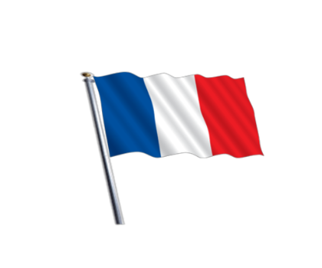  

***Saturday 12th & 26th August***

***10.00 – 11.00am***

***Meets every other Saturday***

*Practise or brush up on your French speaking skills*

*by coming along to an OPEN CHAT SESSION.*

*Fluent speakers, students, starters and anybody wishing to brush up.*

*ALL WELCOME. No booking required – just drop in.*

***Contact Beccles Library 01502 714073 for more information.***